This document contains information from the Arcbotics site (<http://arcbotics.com/>). This document exists to merge relevant information from that site into a single page to avoid having to switch back and forth between web pages.

Setting up Arduino Environment  
  
go to the Arduino website and download the latest version for your operating system  
<https://www.arduino.cc/en/Main/Software>

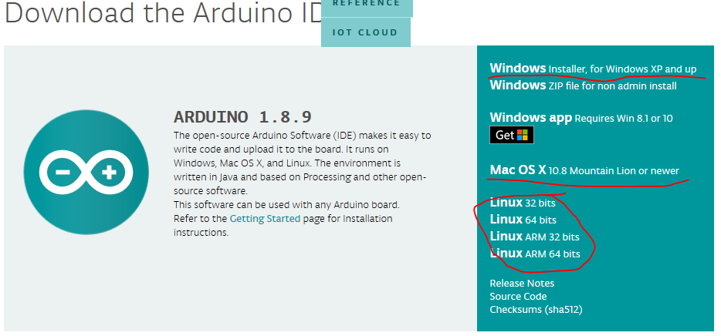  
  
Once the download is complete, run the file to install it.  
  
Open the Arduino IDE  
Click on file -> preferences  
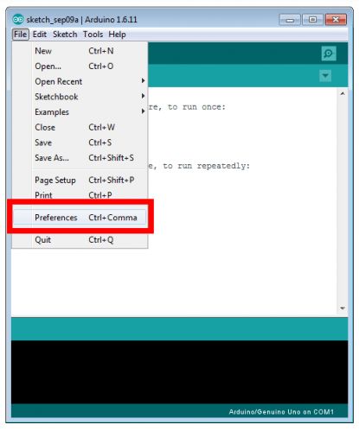

A dialog should pop up. Paste the following url into the highlighted textbox:   
<https://raw.githubusercontent.com/ArcBotics/ArcBotics-Boards/master/package_arcbotics.com_boards_index.json>

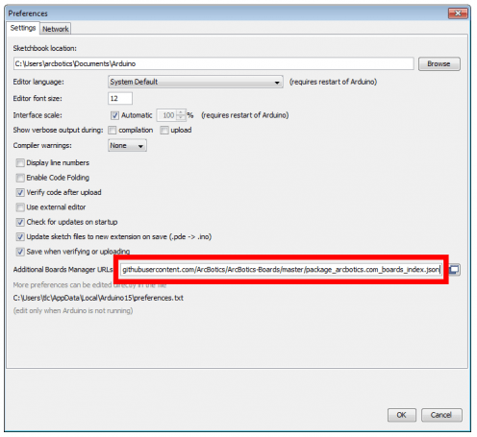  
  
Click OK to save

Click on Tools->board “board type” -> board mangers  
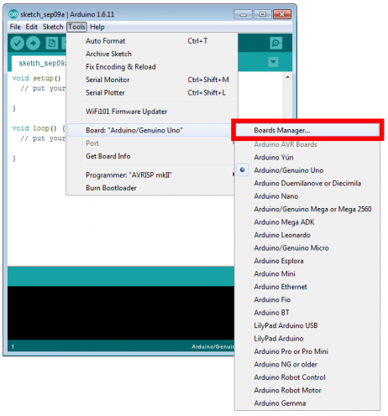  
Click on the drop down box in the upper left corner and select “Contributed”  
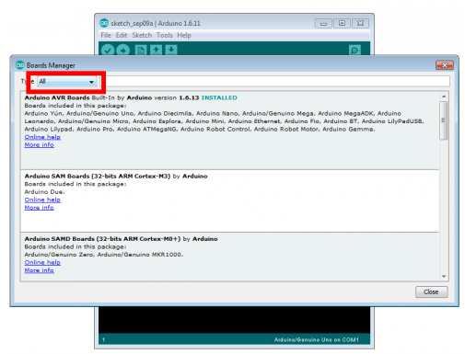

Find the “Arcbotics boards by Arcbotics” and click install  
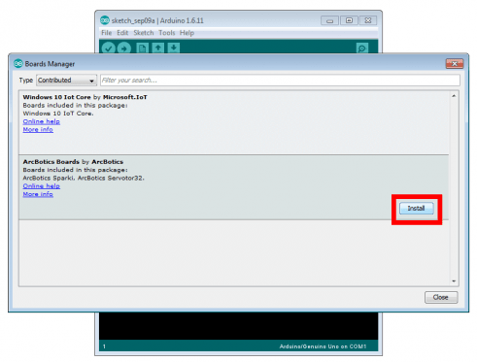  
  
Close the IDE and restart it to ensure everything has been download properly.  
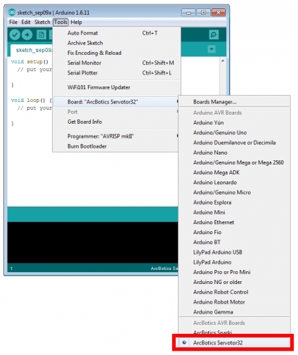

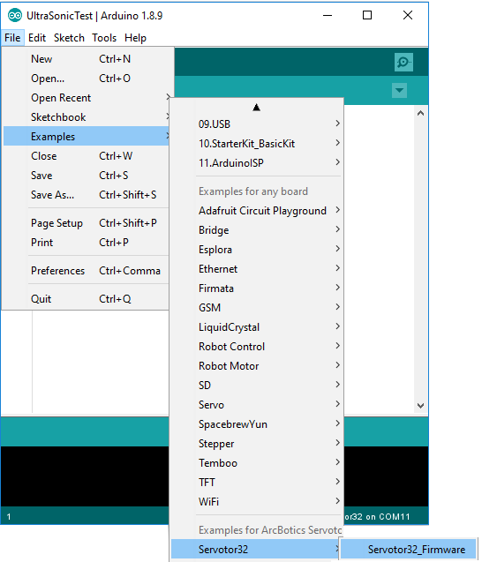

Everything should now be installed.

# Uploading code

To upload your code onto the Arduino, you need to compile your code for the specific board we are using and tell the IDE which com port the board is attached to

## Compiling the code

Go to tools->board and click Arcbotics servotor32 to select the board used by Shrek.  
  


To compile the code, click on the tick symbol in the upper left corner.   
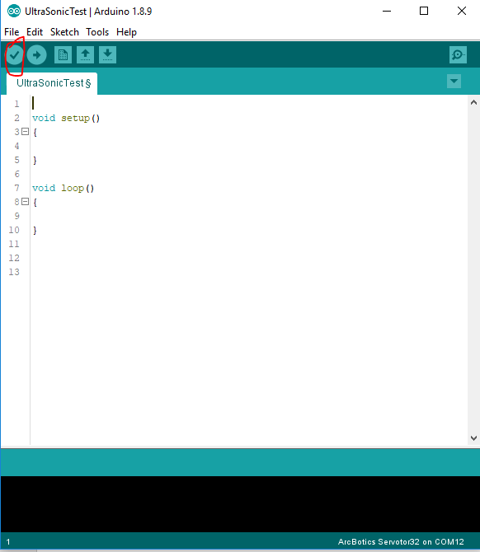

If the compilation failed, you will get some orange messages in the bottom part of the Arduino IDE.  
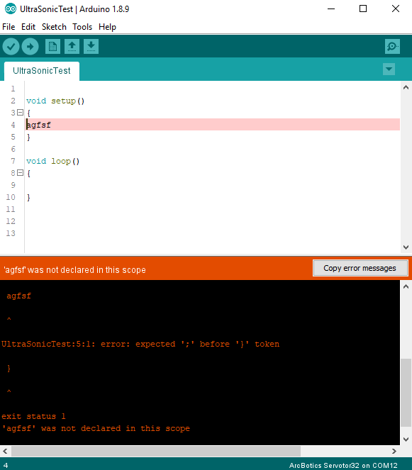

A successful compilation will give information about how much memory is being used and how much is left.  
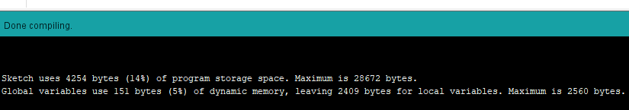

## Uploading the code

To put the code onto the Arduino, you need to tell the IDE what com port the board is connected to.  
Plug the board into one of USB ports on your computer. In the Arduino IDE, click Tools->Port and select the port that says (Arcbotics Servotor 32)

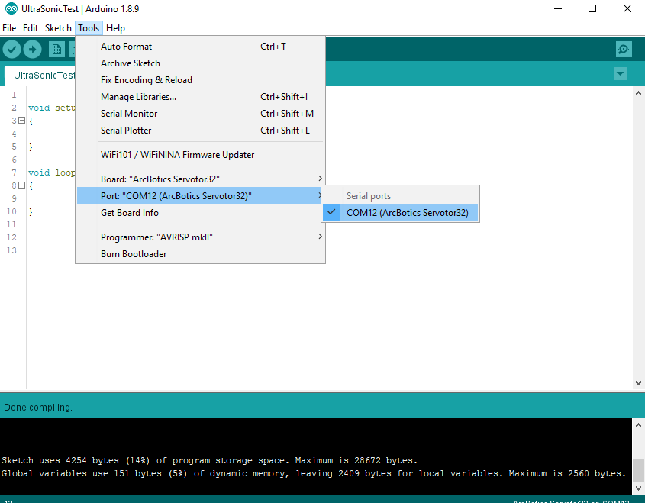  
  
If the “Port” button is greyed out, either the board isn’t connected to your laptop, or you need to try a different USB port.  
  
After the code has been compiled correctly, you can upload it to the board using the arrow symbol in the top left corner.

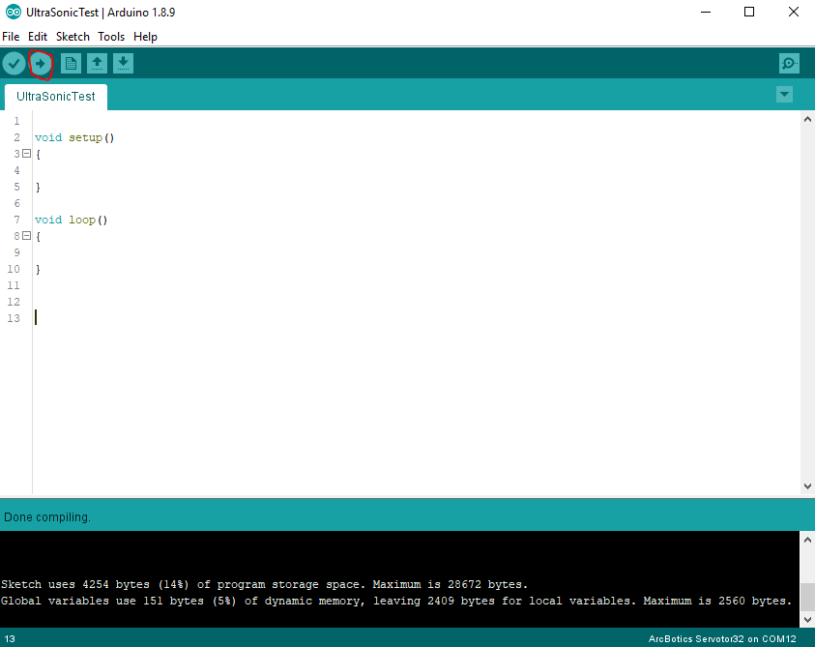

# Using the PoMoCo controller

The PoMoCo controller allows us to use a graphical interface to control Shrek and gain some useful information, but it is rather limited and does not allow for use of the ultrasonic sensor. You can download it from <http://arcbotics.com/lessons/pomoco2-start/>.

Once installing it, open it up and click on the auto connect button to connect to Shrek. You might need to make sure that Shrek is connected to the computer before starting the application.  
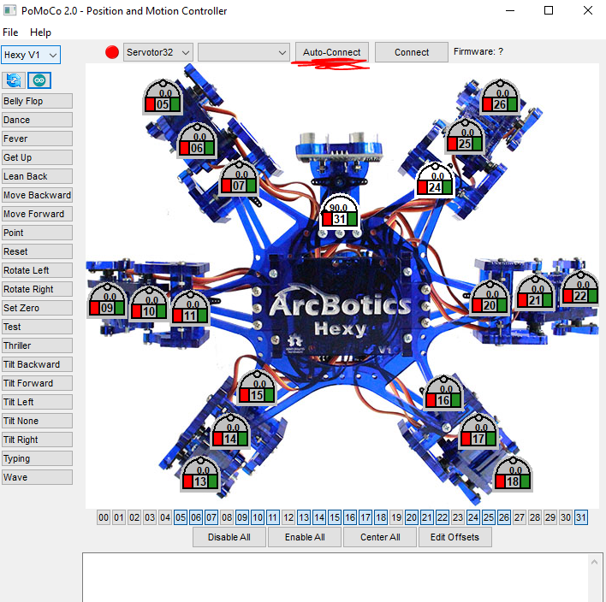

If you are still unable to connect to Shrek, then you might need to re-upload the firmware onto Shrek. The firmware can be found in the example sketches section of the IDE and can be uploaded in the same way as other code mentioned in the Uploading code section.  
  
  
The buttons on the left run Shrek though a hard-coded set of servo positions to recreate a higher level task. The dials in the middle overlaid on top of the hexapod allow you to control individual servos. Click the green box on your desired servo to enable it, then drag the dial around to move the servos. Click the red box when done to disable the servo.  
  
The Arduino symbol in the top left corner allow you to generate Arduino code for certain movements.

